|  |  |
| --- | --- |
| SAB logo (2) | **Learning Together from Safeguarding Adults Reviews (SARs): Adult C** |

|  |  |  |
| --- | --- | --- |
| The East Sussex Safeguarding Adults Board (SAB) has recently published the findings of a Safeguarding Adults Review (SAR), which explored the circumstances leading up to the death of a 41-year-old woman, who is referred to in the report as Adult C.  This briefing summarises the key findings and actions that the SAB will be taking forward in response to this SAR. The full SAR report along with response by the Board and a family statement is available on the [East Sussex SAB website](https://www.eastsussexsab.org.uk/documents/adult-c-sar-published-december-2020-2/). |  | **Sharing learning** is a key priority of the East Sussex SAB. This includes developing strategic learning across agencies and Boards and learning from national best practice and SARs.  All staff and managers are encouraged to discuss this briefing and reflect on the findings, to ensure that the learning outcomes are used to consolidate existing best practice and make improvements where required. |

|  |
| --- |
| **Background to the Review:**  Adult C was found dead by a friend on 31st December 2017. Whilst the cause of Adult C’s death was mixed drug toxicity, Adult C had experienced domestic violence and abuse on many occasions and at times she reported to feel suicidal. There was a complex interplay of many other factors in Adult C’s life, and her presenting issues and vulnerability included:   * Significant levels of domestic violence and coercive control * Poor mental health, including a history of depression and patterns of self-harm * Drug and alcohol dependency * Involvement in criminal behaviour leading to a short-term prison sentence in August 2017 * Periods of street homelessness and barriers in accessing housing provision.   In addition, alternative care arrangements were in place for Adult C’s two children. Whilst Adult C had limited contact with them in the last couple of years of her life, she had spoken of her desire to reinstate more regular contact. This SAR was led by Dr Sheila Fish from the Social Care Institute for Excellence (SCIE) and Alison Ridley an independent reviewer and focused on the last twelve months of Adult C’s life, a period which reflected an escalation in the domestic violence and coercion and control that she was experiencing. |

**Key findings**

**Finding 1: There is currently no accommodation readily accessible for women with the combination of needs related to chronic trauma, drug and alcohol abuse, homelessness and domestic violence and abuse. Women wishing to remain within a couple are even less well served in terms of accommodation. This leaves practitioners having to rely on perseverance and luck to access viable accommodation.**

Safe accommodation is a fundamental need for women with multiple complex needs and securing accommodation was central to Adult C’s safety plans. Yet the complex interplay of Adult C’s needs meant that she experienced a range of barriers in accessing accommodation and standard options were not viable. This was despite the dedicated and persistent efforts of some frontline practitioners and the review commended this good practice.

**Finding 3: There is not currently an established multi-agency protocol or supporting tools for the proactive collection of third-party evidence of patterns of domestic violence and abuse. This leaves police responding reactively to incidents of domestic violence and abuse and trying but struggling to gather viable third-party evidence and leaves the voluntary sector frustrated at inaction against known perpetrators.**

The review highlighted the challenges faced by practitioners in gathering, recording and sharing information in relation to domestic violence and abuse and of how this can be used most effectively in Multi-Agency Risk Assessment Conference (MARAC) meetings, and also how this may be converted into evidence that may be used more effectively within police prosecutions. The agencies working with Adult C held lots of information about the concerns relating to the abuse she was experiencing, but overall, there were gaps in information sharing across different agencies. This meant that a holistic picture of the escalation in domestic violence that Adult C was experiencing was not fully considered, and at times incidents of domestic violence were at times approached as separate entities. The review also reflected how practitioners can lack confidence to report incidents of domestic violence when an adult does not give explicit consent.

**Finding 2: Current service set ups locally are not joined up or tailored to the needs of a small cohort of women who struggle with a combination of needs related to chronic trauma, drug and alcohol dependencies, homelessness and domestic violence and abuse. This leaves some of the most vulnerable women either excluded from services altogether based on eligibility criteria, or unable to access them because of the lack of proactive, flexible and intensive outreach support.**

The review highlighted the challenges faced by services in trying to provide an effective joined up response in working with women with multiple complex needs who have experienced significant trauma. There are limited multi-agency mechanisms to bring together staff across agencies to plan and review their work involving cases which are considered to be high risk and involve individuals who may have varied and complex needs, and to engage all relevant agencies in collective working to develop a ‘team around the adult’. The findings of the review also highlighted the challenges when working with adults whose needs cross statutory frameworks and who may fall just below eligibility criteria, such that there may be a lack of a coordinated response and no lead agency.

**Finding 4: A pattern of continuing to give women with complex needs short term prison sentences at a distance from their home area, disrupts any progress they may be making with the support of community teams, provides little time for specialist health care services delivered within prison to establish relationships, potentially leaving women more vulnerable on their release.**

Women who are given short custodial sentences are often placed out of their area of residence. This creates barriers for services in not being able to maintain active or direct contact with the adult and insufficient time for any meaningful work to be carried out in terms of in-reach services into prisons. For Adult C this compounded her risks and she was released from prison no longer being willing to engage in a residential detox placement and with no accommodation options having been put into place.

**Actions:**

An action plan is being developed by the SAB to take forward learning from this review and make improvements to services. Areas of development will include:

* Contributions towards the new joint strategy for specialist domestic violence services so that accommodation and support services are more joined up and effective in supporting adults with multiple complex needs who are experiencing domestic abuse and coercion and control.
* Considering the development of a multi-agency risk management framework to provide guidance on working with adults where there is ongoing risk, but the circumstances may sit outside the statutory safeguarding framework or service eligibility thresholds.
* Considering the development of multi-agency guidance or tools to support agencies in capturing information in more creative and proactive ways which can support evidence-led prosecutions.
* Seeking improvements to MARAC around ensuring all relevant agencies are involved in meetings and how third-party information can support protection planning more effectively.
* Reviewing and updating SAB multi-agency training around domestic violence and abuse, and coercion and control in the light of any new guidance or supporting tools that are produced.

**Family Perspective:**

SARs have an important part to play not only in relation to effecting changes to safeguarding systems and practices, but in highlighting individual human stories and the impact on adults and their families of experiences of abuse and neglect. Adult C’s mother has provided a statement which has been published with the [Board response](https://www.eastsussexsab.org.uk/wp-content/uploads/2020/12/ESSAB-Response-Adult-C-SAR-Oct-2020-final.docx), of which some excerpts are included below:

* Domestic violence is the primary cause of what went wrong for my daughter and created a barrier for her seeking help and support.
* The agencies working with my daughter should have communicated and shared information about risks more effectively.
* As a family we feel frustrated at the language used by many agencies to describe my daughter as ‘chaotic’ or making ‘lifestyle choices’. Such an approach is victim blaming and does not take account of how circumstances affect the decisions people have to make to keep themselves safe when experiencing such significant and terrifying abuse.



**Further reading and resources**

* [Sussex Safeguarding Adults Policy and Procedures](https://www.sussexsafeguardingadults.org/)
* [Sussex SAR Protocol](https://www.eastsussexsab.org.uk/documents/sussex-sar-protocol/)
* [Sussex Information Sharing Guide and Protocol](https://www.eastsussexsab.org.uk/documents/information-sharing-guide-and-protocol-2/)
* [Research in Practice – Coercive Control](https://coercivecontrol.ripfa.org.uk/)
* [Help and advice about domestic abuse – Safe in East Sussex](https://www.safeineastsussex.org.uk/domestic-abuse-help.html)
* [MARAC information – Safe in East Sussex](https://www.safeineastsussex.org.uk/MARAC-help.html)

A range of safeguarding courses, including in relation to domestic violence and abuse, and coercion and control are available through the [East Sussex Learning Portal](https://eastsussexlearning.org.uk/).

All staff and managers are encouraged to reflect on the issues presented in this briefing. Together with your teams consider how you can challenge your own thinking and practice in order to support continuous learning and development. Ask yourself:

* Can I make changes to my own practice?
* Do I need further support, supervision and training?
* Is there anything in my organisation that needs to change so that it can support best practice?

For more information about this SAR contact Delyth Shaw, SAB Development Manager at [Delyth.Shaw@eastsussex.gov.uk](mailto:Delyth.Shaw@eastsussex.gov.uk)

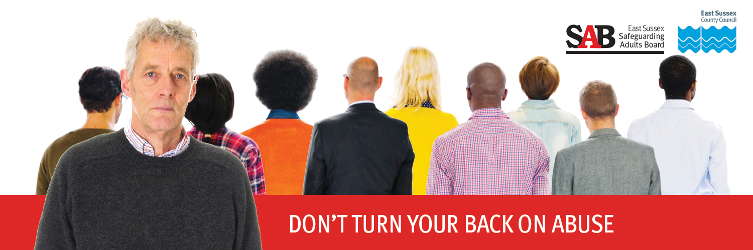Follow the latest East Sussex SAB news on our [website](https://www.eastsussexsab.org.uk/) and on Twitter @SAB_EastSussex