East Sussex Safeguarding Adults Board Monthly Digest
September 2023

This latest roundup includes information on Suicide Prevention Day, Identifying and Working With Self-neglect in People Experiencing Homelessness guidance, Survivors Network Change the Culture Training Sessions, Trauma Informed Practice Training, Support and management of Alcohol-Related Brain Damage Conference, Foetal Alcohol Spectrum Disorder Month, and upcoming Training opportunities.
Have an interesting item? Please get in touch ESSAB.Contact@eastsussex.gov.uk
_________________________________________________________________________
Suicide Prevention day
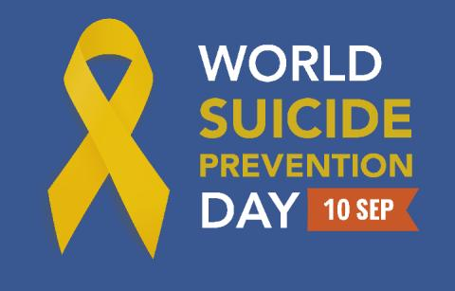
The 10th September each year aims to raise awareness of suicide to reduce stigma and focus attention that suicide is preventable.
‘Warning signs’ is a suicide prevention campaign in Sussex, specifically aiming to support the reduction of annual suicide amongst men. It has been developed and led by Sussex Health and Care Partnership.
For anyone seeking support and advice for their mental health or suicide prevention, you can access the East Sussex Mental Health Directory.
_________________________________________________________________________
Identifying and working with self-neglect in people experiencing homelessness guidance
The London Network of Nurses and Midwives Homelessness Group have produced a piece of guidance on identifying and working with self-neglect among people experiencing homelessness.
The guidance specifically outlines the legal framework that practitioners can utilise to provide the crucial advocacy that is often needed to ensure a person’s needs can be met by a range of agencies. ___________________________________________________________________
Survivors’ Network Change the Culture Training Sessions
Survivors Network have released new dates for their popular training packages as individual sign-up sessions in Autumn. The Change the Culture sessions are held over Zoom for individuals and smaller groups at fixed times. This is an exciting opportunity to learn from frontline experts on the prevalence and realities of sexual violence, whether that might help you in your professional or personal life.
_________________________________________________________________________
Trauma-Informed Practice Training

Changing Futures are offering 90-minute Trauma Informed Practice training sessions for people based in Sussex working with people experiencing multiple disadvantage.
The training focuses on
- what Trauma is and what Trauma Informed Practice is,
- realise the prevalence of trauma amongst colleagues and people you are working with,
- recognise how trauma may affect people and contribute to their behaviours,
- introduce frameworks for responding to trauma,
- begin to consider how to apply trauma informed approaches to your working practice.
_________________________________________________________________________
Support and management of Alcohol-Related Brain Damage Conference
On 5 October, Alcohol Change UK and the ARBD network will be hosting a free one-day online conference on alcohol related brain damage (ARBD). The conference will explore the challenges and latest developments in dealing with ARBD and the solutions in supporting those affected. Through a blend of talks and workshops, experts in this area will share their experiences and knowledge, providing valuable insights for professionals and individuals involved in the care and support of those affected by ARBD.
___________________________________________________________________
Foetal Alcohol Spectrum Disorder (FASD) Awareness Month
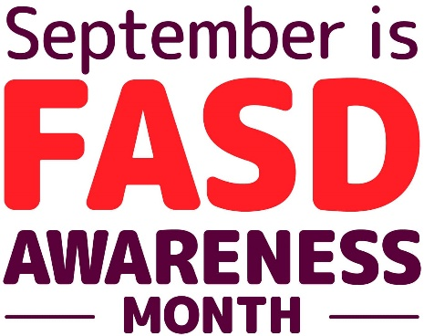
September is FASD awareness month. Informed practitioners can make the world of difference in the lives of people with FASD and their families.
The National Organisation of FASD offer e - learning, and in person or virtual training focusing on the cause of FASD, identifying the signs and symptoms, and strategies for supporting a person with FASD. You can also find a wealth of information on their website.
Also, check out the NICE Quality Standard on FASD which covers assessing and diagnosing FASD in children and young people. It also covers support during pregnancy to prevent FASD. It describes high-quality care in priority areas for improvement.

_________________________________________________________________________
Safeguarding Training
Please see details below of the East Sussex Safeguarding Adults Board (SAB) multi-agency training courses with places still available. All these courses can be found on the Safeguarding page on the Adult Social Care section of the East Sussex County Council Learning Portal.

Please cascade this information to relevant staff within your agencies and promote these opportunities for continuing professional development.
Click on the link to see details of the course you are interested in. You will find the course booking form at the foot of each course description. You do not need an account to make a course booking.
Courses may be delivered face to face or virtually so make sure you check the course details when booking.

- 26.09.2023 SAB: Mental Capacity Act 2005: A Multi-Agency Approach to Complex Cases
- 26.09.2023 SAB: Modern Slavery Awareness Workshop
- 24.10.2023 SAB: Multi-Agency: Self Neglect training
- 05.02.2024 SAB: Domestic Abuse: DASH, MARAC, and Safety Planning Training
- 06.11.2023 SAB: Mental Capacity Act 2005: A Multi-Agency Approach to Complex Cases
- Mental Health Conditions Awareness Training – The next course on 11th September is full, but please check for further dates.
Our colleagues in the East Sussex Safeguarding Children Partnership (ESSCP) offer courses that are also available to SAB partner agencies. Details of forthcoming ESSCP courses which currently have places available are listed below:
- 21.09.23 ESSCP: Adultification of Black, Asian, and Minority Ethnic (BAME) Communities - Addressing Barriers to Safeguarding Children Effectively & Appropriately
- 31.10.23 ESSCP: Professional Curiosity and Professional Challenge within a Safeguarding Context
- 05.10.23 ESSCP: Young People and Abusive Relationships
- 09.10.23 ESSCP: Female Genital Mutilation (FGM) and Breast Ironing - identifying and challenging harmful traditional practices
- 16.10.23 ESSCP: Honour Based Violence and Forced Marriage - identifying and challenging harmful traditional practices
e- Learning:
Some courses have prerequisite e-Learning to be completed before you attend the course. If your course requires you to complete e-Learning this will be explained in the ‘Additional Information’ section in the course details. To see all e-Learning modules please visit e-learning site. You will need to create an account to access the e-Learning.
_________________________________________________________________________

Get in Touch – We would love to hear from you!
Suggestions or comments are welcome, or if you wish to unsubscribe contact us at ESSAB.Contact@eastsussex.gov.uk

You can follow the latest East Sussex SAB news on our website and on Twitter @SAB_EastSussex

