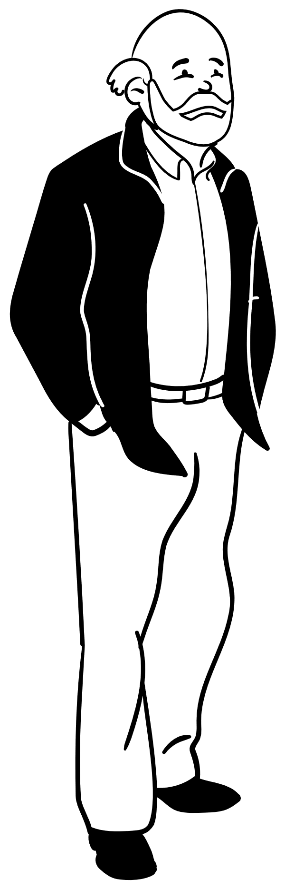
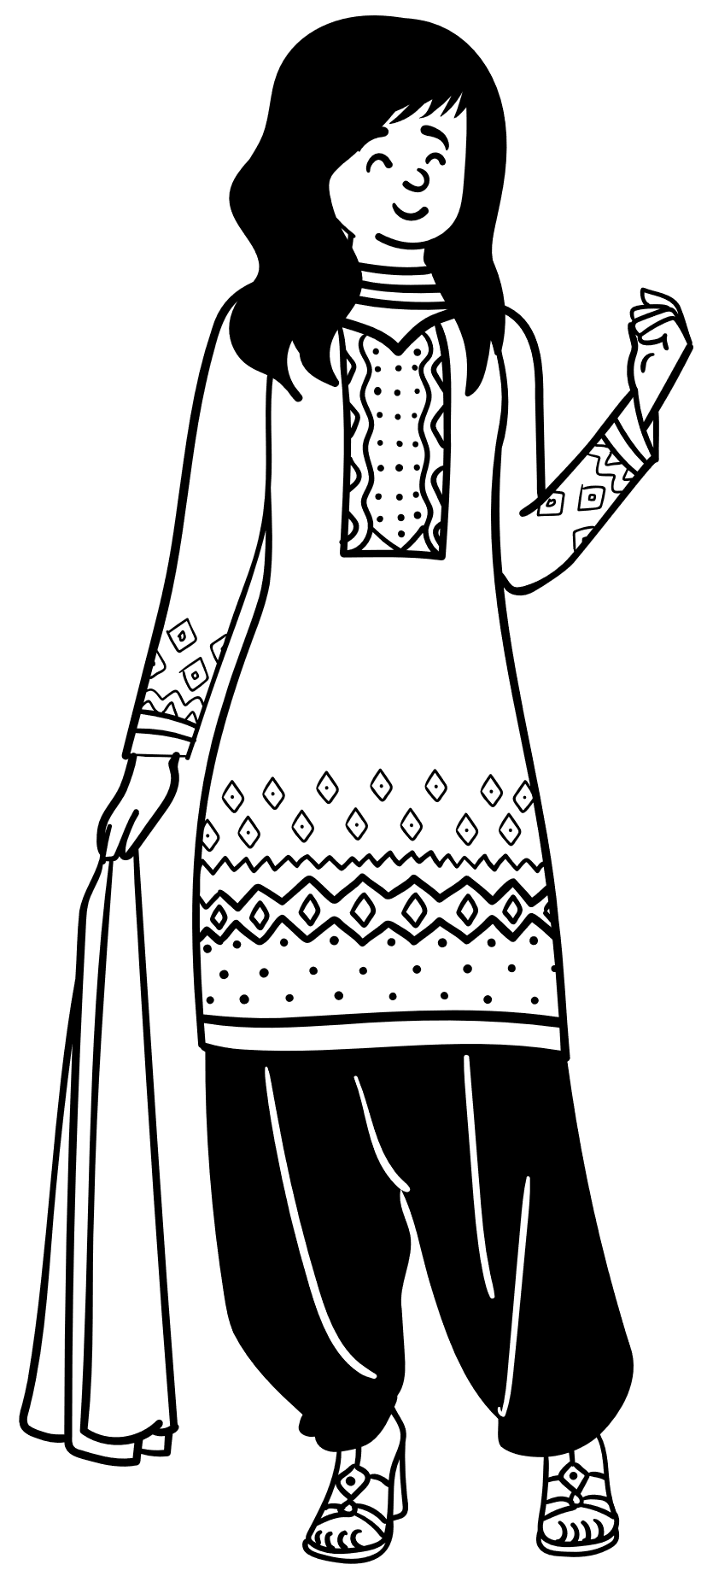

Mental Health Conditions:
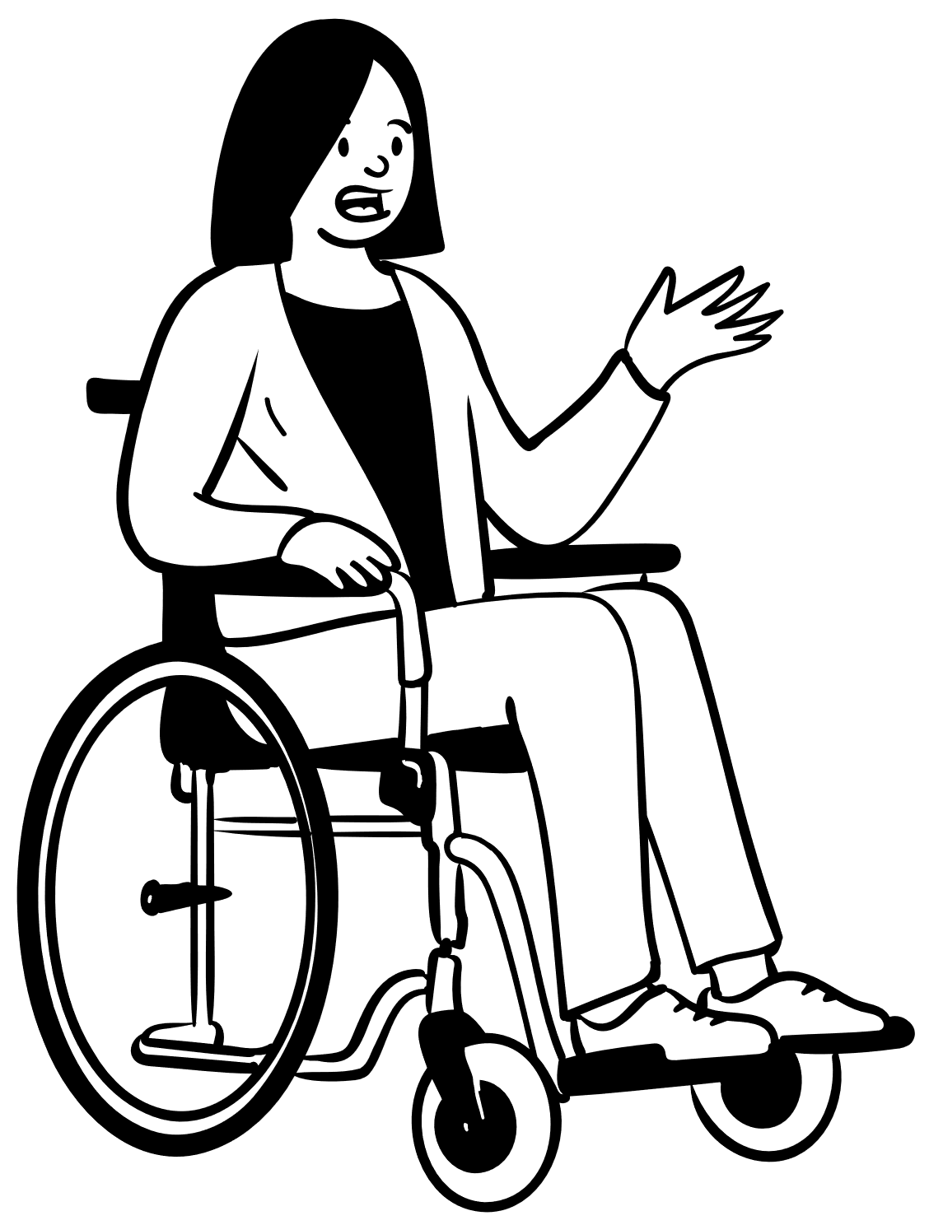
Awareness

Information Pack

February 2024

Contents

Contents 2
The difference between primary and secondary mental health care? 3
Local Mental Health support services 4
Commissioned community mental health support services 5
Types of Mental Illness 7
For people in crisis and suicide prevention 8
E-learning Suicide Awareness Training 8
Safeguarding 8
Substance Misuse – How to get help in East Sussex 9
Online support 9
Person-centred communication 10
Money worries and mental health 11
Cost of living support 11
Employment support for people with mental health diagnoses 11
Further Training 12

The difference between primary and secondary mental health care?

Primary care is often the first point of contact for people in need of healthcare. It is provided by professionals such as GPs, and pharmacists, and increasingly, MH practitioners based in groups of GP practices called Primary Care Networks (PCNs). Secondary care generally involves a referral to secondary mental health services from a GP. In Sussex these services are delivered by the ‘mental health trust’ – the Sussex Partnership NHS Foundation Trust (SPFT). The SPFT services include:

- Acute care (inpatient care in hospital, in East Sussex these are Woodlands, St Leonards Conquest, DoP Eastbourne DGH - to be replaced with Combe Valley Hospital Bexhill from Spring 2025, and Amberstone Rehabilitation Unit, Hellingly Centre
- Community mental health teams (CMHT), in Sussex these are called the Assessment and Treatment Teams (ATS) based at Assessment and Treatment Centres (ATCs)
- Crisis resolution and home treatment teams (CRHT)

The ATS supports people with mental health problems living in the community. The ATS teams can include a community psychiatric nurse (CPN), a psychologist, an occupational therapist, a counsellor, and a community support worker, as well as a social worker.
The CHRT can provide safe and effective care in a person’s own home if they have a mental health crisis outside hospital and need urgent mental health support. For example, this may be because of psychosis, severe self-harm, or suicide attempts. Crisis teams can also support someone to plan for future crises, to prevent this happening again in future, as well as to support them as they leave hospital. The CHRT team usually includes several mental health professionals, such as a psychiatrist, mental health nurses, social workers, and support workers.

When people become mentally unwell, they can choose to present themselves (usually to their GP who may then refer them to secondary services) and then cooperate with the suggested treatment, very rarely needing to voluntarily admit themselves as an inpatient. Alternatively, someone may not recognise how unwell they are, and need to be assessed under the Mental Health Act. This may lead to them being ‘sectioned’ and admitted to a psychiatric hospital against their wishes for the treatment they need to start their recovery.
When someone is discharged from hospital, they may be entitled to ongoing Section 117 aftercare in their community to help keep them well. This can include healthcare, social care and employment services, supported accommodation and other services to help with social needs.

The Adult Social Care department and the Sussex Clinical Commissioning Group (now called NHS Sussex and merged into our Integrated Care Board) have a responsibility to commission local health and care services in the community, to meet the holistic needs of people with mental health difficulties. The main services are outlined in the following pages.
Many people also find amazing support in their local communities through our numerous community and voluntary organisations – these are funded through a mixture of contracts, grants, and voluntary donations.

Hints & Tips

Remember, no individuals’ experience of their condition will be the same as someone else,
always use the personalised approach and focus on them rather than their condition.

Always display respect, even if they may seem under the weather – remember, using a positive approach is likely to enhance their temperament.

Be patient and show active listening when they speak even if you do not understand as this can contribute to them feeling valued and it shows that you care.

In circumstances where they may be acting aggressively or raising their voice, it is
likely that this is not directed at you.

Local Mental Health support services

If someone is suffering with their mental health they should initially speak with their GP, or if they have one, their Lead Practitioner in the Community Mental Health team.

Sussex Mental Health Crisis Line
Phone: NHS 111 and select mental health option
Website: 24/7 Mental Health Crisis Line

This helpline is for mental health care and advice, open 24/7, for all ages for anyone who has a concern themselves or someone else, no referral is needed. The Healthline staff are trained to assess someone’s mental health and help them access appropriate support. This may include support provided by the crisis team. For callers whose first language is not English, a telephone interpreter can be arranged for other community languages, by phoning the helpline and letting them know the language needed. If you are concerned about an immediate risk of harm, then phone 999. Other information and mental health resources can be found in the East Sussex Mental Health Directory.
Local Mental Health support services

Health in Mind
Phone: 0300 003 0130
Website: Health in Mind
A free NHS psychological therapy service for East Sussex residents who are experiencing stress, anxiety, or low mood. People can self-refer through the website and find videos, top tips, and free online therapy programmes. Once a referral has been received, the team will talk to the applicant about what can be offered based on their needs. Please note that the service is funded to treat anxiety and depression and people with more complex mental health needs or diagnosis may need to seek more specialist help through their community MH team.
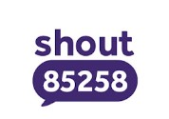

Shout Sussex texting service
Website: UOK Brighton & Hove
By texting the word SUSSEX to 85258, people can access people can access a free, confidential, 24/7 service to have a text conversation with a trained volunteer. The volunteers offer real-time support to people who are anxious, stressed, depressed, suicidal or overwhelmed and need immediate support. Some people will prefer this to speaking on the phone. If needed, texters will be signposted to other services.
There is a short video about Shout (this is the national service – the Sussex service is the same but links with our local support).

Commissioned community mental health support services
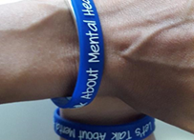
Southdown is a large voluntary sector organisation operating across East Sussex, where they are commissioned to deliver several services.
These include community support for people with significant mental health challenges, through a set of connected services collectively called the Mental Health Support Services (MHSS). These services are delivered from seven local wellbeing centres and also offer some virtual groups. Clients are supported to stay well and prevent crisis.

Wellbeing Centre Service webpage and Referral form or contact 01323 405334 / ESCN@southdown.org for general enquiries or to discuss a potential referral.
Following an assessment, a Wellbeing Recovery Worker will work closely with the client to develop a personalised wellbeing plan. They can also give support to access wider activities and groups at the centres and in the local community. Peer Support can also be offered by people with lived experience of a mental health diagnosis.

Wellbeing in East Sussex is a Mind
project that promotes the emotional and mental
wellbeing of people living with mental health issues across East Sussex.
More information on Wellbeing in East Sussex, or
Email: info@mindcharity.co.uk Telephone: 01273 66 69 50

Staying Well Space is an out of hours mental health crisis (AKA crisis café) service, delivered in two of the Southdown Wellbeing Centres (St Leonards and Eastbourne) and open 4pm to 10.30pm on weekdays and 3pm to 10.30pm at weekends (see website for individual café opening schedules).

The service is for any adults living with urgent mental health support needs, and access can be either by self-referral or by a professional on their behalf. The objective is to help people through their crisis, offer them tools and prevent the need for them to make a trip to A&E out of hours. The service is staffed by skilled Recovery Workers and Peer Supporters (with lived experience), who offer tailored recovery-focussed support alongside non-judgemental listening and advice.
Phone – 0800 0236 475 for queries or to discuss a referral or
Email: StayingWell@southdown.org Website: Southdown Staying Well Space

Community Connectors is our commissioned mental health Social Prescribing service, working in partnership with GP Practices across Hastings & Rother, and Eastbourne, Seaford & Hailsham. They support residents to link in with community groups, activities and services and have demonstrated that this personalised goal-setting approach has a significant positive impact on clients’ mental health and wellbeing Anyone with an issue which is impacting on their mental health can be referred (by their GP or other professional) or self-refer. The Navigator works closely with the client, first identifying the main issues and goals, and then over several sessions supporting them to connect to the areas illustrated as needed. Community Connectors also have a Buddy Volunteer service to support people who may need extra help and confidence to access groups, activities, and learning, online or in person.

Your clients may benefit from this service, and you are welcome to promote it or contact them the team to find out more.

Website: Community Connectors and Referral form
Email: social.prescribing@nhs.net or call 01323 340151 for more information.

Side by Side is an excellent national peer support online community, open 24/7 to anyone with a mental health difficulty to connect with others. Website: Side by Side

Types of Mental Illness

Stress - Stress is a part of our day to day lives which we all experience, it helps us to meet the challenges we are exposed to and can provide us with the strength and ability to deal with difficult situations. A small amount of stress is healthy and can be the drive that allows us to face everyday ups and downs. If stress becomes overpowering it can affect our physical, mental, and emotional responses and lead us to feel like we are unable to cope.

Depression - Depression is a term that is commonly used if a person is feeling low, sad, or unhappy, however this is not classed as depression as it is short term and people recover relatively quickly without any forms of treatment. Clinical depression lasts for long periods of time usually weeks and can affect a person physically, mentally, and emotionally and have a negative impact on the way they feel, think, and behave.

Anxiety - We all get anxious from time to time, and everyone will have different situations or events that will make them feel tense or uneasy. Anxiety is defined as a continuous symptom of stress which will affect a person’s quality of life. When a person is anxious, they will have physical feelings and worrying thoughts which can affect their ability to cope with everyday tasks.

Personality Disorders - If someone has a personality disorder (also known as Complex Emotional Needs), some aspects of their personality might affect them in a way which makes it very difficult to cope with day-to-day life, especially when it comes to relationships. For example, they might be more or less sensitive, impulsive, prone to anger, or obsessive than others.

Psychosis - Psychosis is a medical term used to describe hearing or seeing things that do not exist or believing things that other people do not. Common examples include hearing voices or believing that people are trying to do you harm. A person can experience psychosis for a wide variety of reasons. For example, it can be due to having a mental illness such as schizophrenia or bipolar disorder. It may be caused by drug use, brain injury or extreme stress.

For people in crisis and suicide prevention

1 | 2 | 3 | 4 | 5 | 6
1) Ensure your own personal safety | 2) Do not get involved physically | 3) Call for assistance | 4 Ensure the person is not left alone | 5 Remove any possible aids | 6 Encourage communication

E-learning Suicide Awareness Training

The following training is recommended to anyone who may encounter family, clients, strangers, or work colleagues you may be concerned about. You can access a certificate of completion.
The learning is free and there are other useful e-learning courses on this website.
Suicide Awareness Training (20 minutes)

Older Adult Suicide Prevention Hub - Grassroots Suicide Prevention (prevent-suicide.org.uk)

Safeguarding

If you are aware of an adult who is expressing suicidal ideation, has care and support needs and is also experiencing or is at risk of abuse or neglect, then a safeguarding concern should be raised with Health and Social Care Connect (HSCC). Phone: 0345 60 80 191

If you are aware of an adult who is expressing suicidal ideation, but there is no indication this person is experiencing or is at risk of abuse or neglect, or you are not sure if this person has care and support needs but is experiencing or is at risk of abuse or neglect, these concerns should also be raised with HSCC.

If you are concerned the adult is in immediate danger, please contact the emergency services first.

Sussex Safeguarding Adults Thresholds Guidance

Substance Misuse – How to get help in East Sussex

STAR (Change Grow Live)  This service helps users to regain control, change the direction of their lives, grow as a person and live life to its full potential  Available across East Sussex  Phone: 0300 303 8160  Email: EastSussex.Firststep@cgl.org.uk  Website: STAR | East Sussex Recovery Alliance (ESRA)  Drug and alcohol recovery service for those over the age of 18  Website: ESRA

Adfam East Sussex
This service provides direct support to families and carers through information, one-to-one support and group and peer support

Website: Adfam East Sussex for further information and to make a referral.

Online support
These services are offer helplines, online meetings, and information to support recovery from substance misuse:
- Alcoholics Anonymous (plus free 24-hour helpline 0800 917 7650)
- Alcohol rehab support
- Narcotics Anonymous App & online meetings - (plus helpline 0300 999 1212 daily, 10am to midnight)
- SMART Recovery (self-management and recovery training for addiction)

Support for Carers in East Sussex
In East Sussex Care for the Carers support anyone who gives unpaid care. The Mental Health Carers Project supports carers for people with a severe mental illness. Further carer support can be found on the ESCC website www.eastsussex.gov.uk/social-care/carers

Person-centred communication

Illness view

Focuses on treating problems and deficits

Focuses on brain

People are either mentally ill or mentally healthy

Directed by professionals as experts

Rehabilitation with the aim of the person
Keep the person occupied while waiting for the treatment to work

Well-being view

Focuses on strengths and what helps achieve well-being

Considers mind, body, and spirit

We are all on a continuum of mental well-being

A personal journey of self-management with peer

Work with the person to help them identify and achieve goals

Each person will find their own meaning in personal experiences and their own definition of recovery

Illness view

Well-being view

A well-being view is not about ignoring an individual’s problems and needs but about seeing the whole person and supporting changes that may have a positive impact on those areas of their life that are not going well

Empathetic understanding: Understanding the person you are supporting from their point of view, being with them in their world and trying to stand in their shoes

Acceptance or unconditional positive regard: being able to suspend judgment and criticism

Genuineness: the ability and willingness to be open, real, and consistent; not wanting to manipulate or patronise

Money worries and mental health

Welfare benefits service and financial advice - free, confidential advice and information. Open to people living in East Sussex, Mon to Fri, 9am to 5pm. Phone 0333 344 0681 (03 calls cost no more than 01 or 02 numbers)
Welfare benefits helpline Website

This national impartial organisation with a mental health focus has lots of advice and information on managing money, debts, and benefits. And a toolkit to help people understand, manage, and improve their mental and financial health.

There’s also lots of information on self-help and national support organisations and resources on our Mental Health and money worries pages.

The Money & Pensions Service have a useful Money Guiders programme which may be useful to you if you have money conversations with your clients.

Cost of living support
For those who are worried about the cost of living here you will find information and sources of support available in East Sussex East Sussex County Council – Cost of living support webpage

Employment support for people with mental health diagnoses
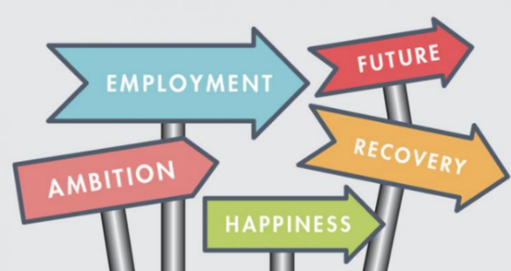
Southdown Individual Placement and Support (IPS) service works with people who want to get back into employment and continue to support them while in work. IPS staff offer individualised support for the person and their employer for as long as is needed.
Referral is usually through the secondary mental health services (SPFT) although there are moves to allow self-referral in future.

Skills and Employability Support East Sussex – An online brochure full of the latest information on free to access skills, employment and other support, arranged by area.

Work in Mind – One to one support to find and retain employment, self-employment, voluntary work and education for adults (aged 18 years +). Referrals are accepted direct from Health in Mind teams only.

Further Free Training
East Sussex Learning Portal offer the following nationally recognised qualifications in partnership with outside training organisations which can be completed online:

Level 2 Certificate in Counselling Skills
Level 2 Certificate in Equality and Diversity
Level 2 Certificate in Improving Personal Exercise, Health and Nutrition
Level 2 Certificate in Awareness of Mental Health Problems
Level 2 Course in Mental Health in the Early Years
Level 2 Course in Understanding Men's Mental Health
Level 2 Certificate in Living in a Fair and Diverse Society
Level 2 Certificate in the Principles of the Mental Health Care Worker

Recovery College Online Provides a range of online educational courses and resources to people who might be struggling with mental health issues, families, friends, mental health workers and anyone else who might be interested.

Sussex Recovery College | Mental Health & Recovery Courses are free to adults of all ages. Whether you’re looking to develop your knowledge and skills in self-management, you support somebody with mental health-related challenges, or you work in the mental health services, they will welcome you on a learning journey.

Learning Pool MH Awareness online course – approx. 40 mins, good content, particularly on anxiety and depression and schizophrenia – no certificate issued.

https://www.reed.co.uk/courses/free/mental-health-training

Reading, Videos, and Podcasts

Mental Health Conditions - NHS | Understanding mental health problems - MIND
Anxiety and Panic Attacks – MIND | Bipolar Disorder – MIND
Drugs – Recreational drugs and Alcohol - MIND | Eating problems – MIND
Hoarding - MIND | Obsessive-compulsive Disorder - OCD – MIND
Post-traumatic stress disorder - PTSD - MIND | Psychosis – MIND
Schizophrenia - MIND | Suicidal Feelings – MIND
Depression – MIND  Seasonal affective disorder (SAD) | What are mental health problems YouTube video
Emotional Energy – Mental Health at Work | Podcasts and videos | Mental Health Foundation
Podcasts - Mind – What it’s like to live with mental health problems | Talking to someone about Mental Health Guide
Websites  www.mind.org.uk  https://www.rethink.org/ | Top tips to improve your mental wellbeing - Every Mind Matters - NHS (www.nhs.uk)  Skills for Care  www.skillsforcare.org.uk

